Reading a Discussion Board

Once you have entered a forum, you will see a listing of threads available within that forum.

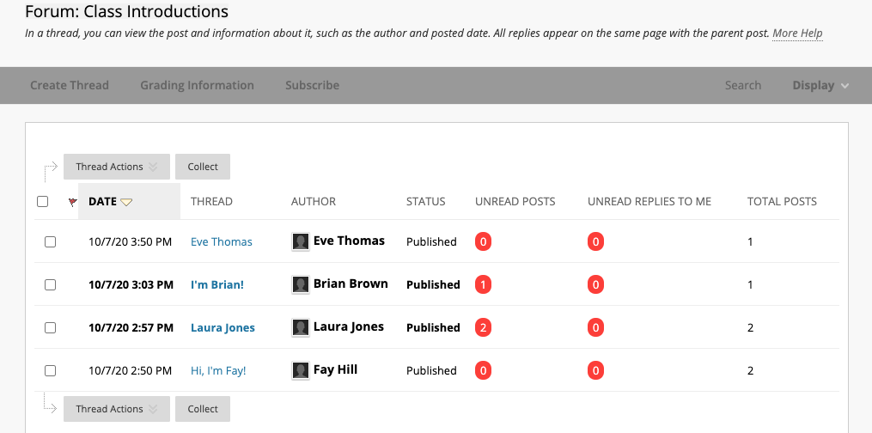

Each line represents a unique thread that someone has created. A thread represents a series of posted messages strung together, similar to a conversation.

As more posts are added, the thread becomes longer. Each thread listed on the forum page is like an opening line to a discussion from a person.

From this page, you can also see the total number posts within a thread, posts you haven’t read, and the replies to you that you haven’t read.

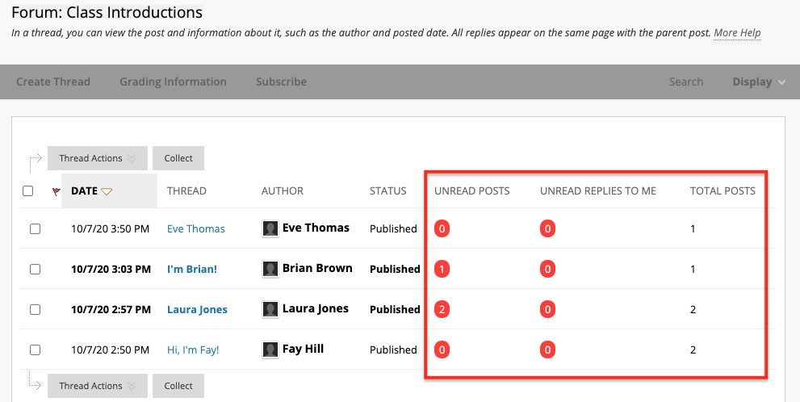
The thread title of unread posts and replies appear in bold. The number of unread posts you have in a thread will appear in a red circle.

To read an individual post within the discussion forum, click the thread title.

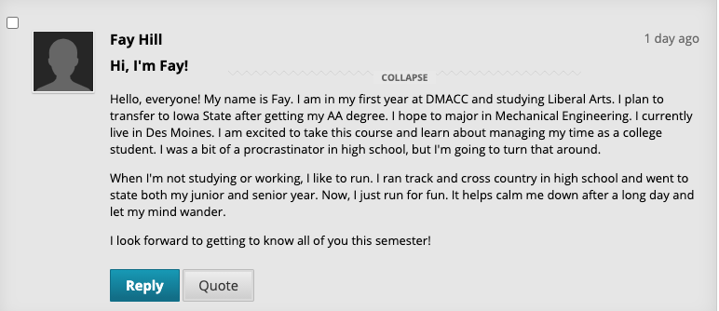

If there are additional posts or responses in the thread, you will see them below the original.

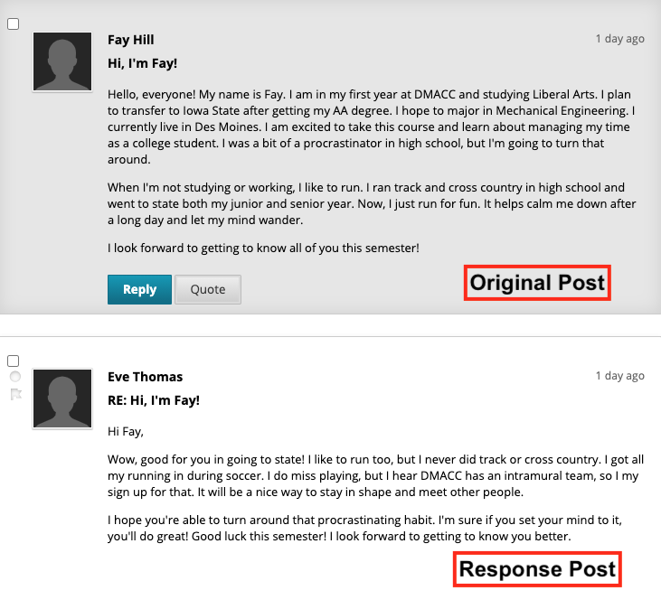

To switch threads, click at the bottom of the page. This will return you to the main forum page. You can click on another post at that time to read the thread.

You can add your thread to the discussion by clicking the button.

Some discussions will require that you add your own thread before you can view your classmates’ threads. They are often called post-first discussions.

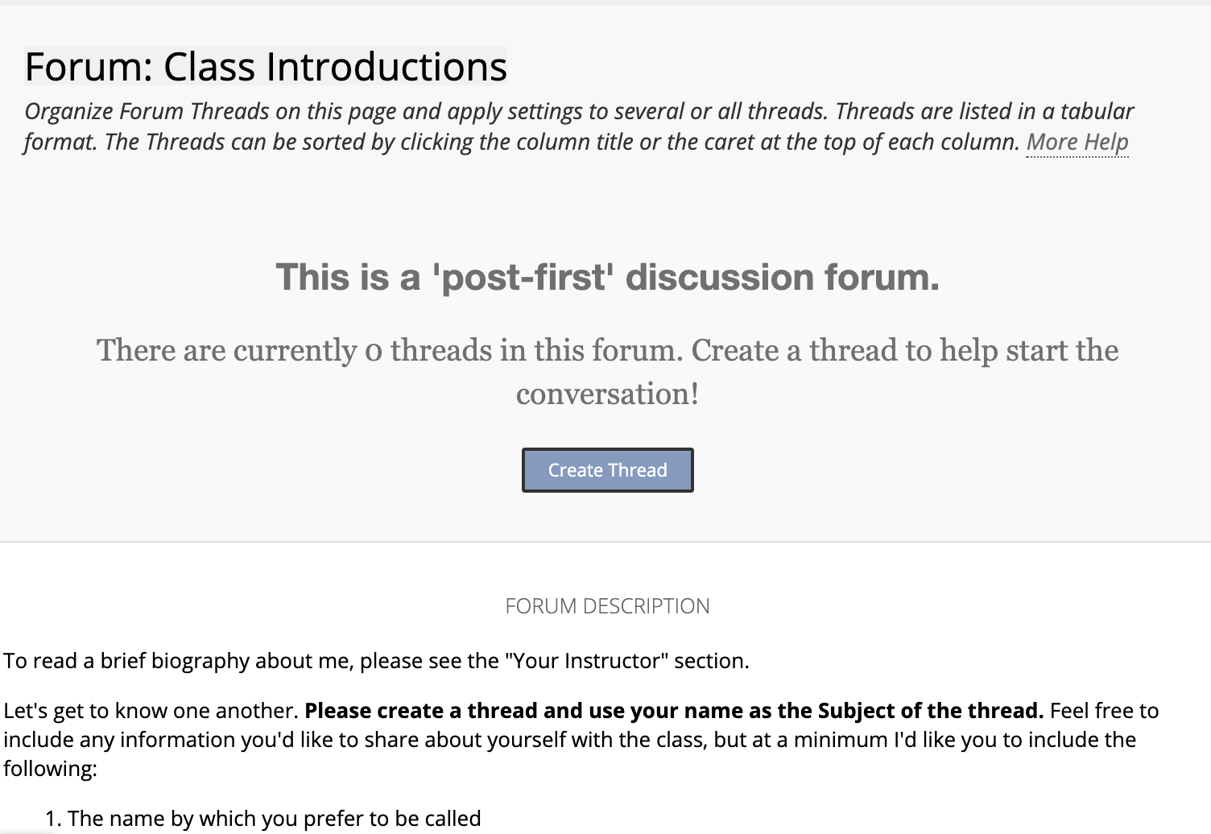

Next, refer to the document on Participating in a Discussion Forum to learn about adding threads and replies.

